Graphic User Interface

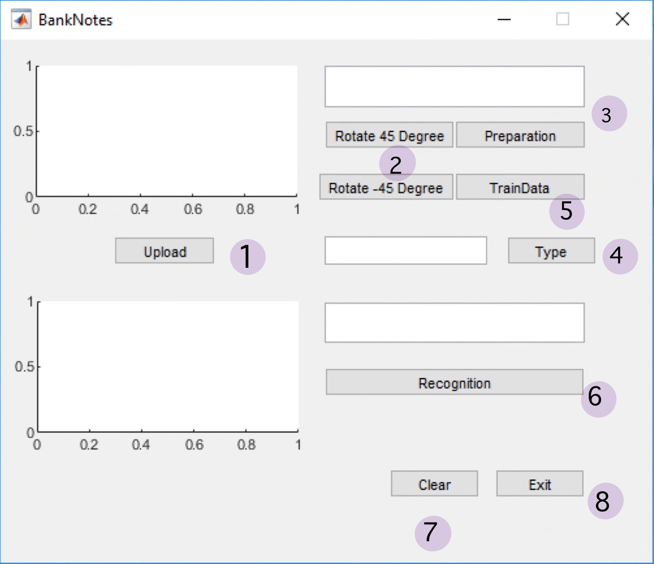

Implementation

1. Upload

global image;

global pic;

global filename;

[filename pathname]=uigetfile({'*.bmp','*.jpg'},'file select');

image = strcat(pathname,filename);

pic = imread(image);

axes(handles.axes1); imshow(pic);

axes(handles.axes2); cla;

set(handles.edit1,'string',filename);

1. Rorate 45 or -45 degrees

global pic

pic = imrotate(pic,45);

% imrotate(pic,-45)%

axes(handles.axes1); imshow(pic);

1. Preparation [Crop an object]

global pic;

hsvImage = rgb2hsv(pic);

sImage = hsvImage(:, :, 2);

mask = sImage > 0.1;

mask = bwareafilt(mask,1);

mask = imfill(mask, 'holes');

props = regionprops(logical(mask), 'BoundingBox');

croppedImage = imcrop(pic, props.BoundingBox);

axes(handles.axes1); imshow(croppedImage);

1. Color Recognition

global pic;

r=mean(mean(pic(:,:,1)));

g=mean(mean(pic(:,:,2)));

b=mean(mean(pic(:,:,3)));

Thou = abs(r-b);

%Thou > 3 is not 1000%

onethou = false;

if Thou <=3

onethou = true;

end

if (r > g) && (r > b) && (onethou == false)

set(handles.edit3,'string','100');

elseif (b>r) && (b>g)&& (onethou == false)

set(handles.edit3,'string','50');

elseif (g>b) && (g>r) && (onethou == false)

set(handles.edit3,'string','20');

else

set(handles.edit3,'string','1000 or 500');

end

1. Preparing data for Euclidean distance Recognition [Train]

global pic;

global filename;

global excel;

excel = 'E:\MATLAB\R2018\bin\Project\DB_Train.xlsx';

tab=xlsread(excel);

[rr,cc]=size(tab);

% ............................ Calculate Features

mred=mean(mean(pic(:,:,1)));

mgreen=mean(mean(pic(:,:,2)));

mblue=mean(mean(pic(:,:,3)));

gray=rgb2gray(pic);

mgray=mean(mean(gray));

%energy

gray=rgb2gray(pic);

glcm = graycomatrix(gray, 'o', [0,1]);

S = graycoprops(glcm);

energy = S.Energy*100;

%entropy

rngfil = rangefilt(pic);

entro = entropy(rngfil)*100;

%homo

Homo = S.Homogeneity*100;

%contrast

Contrast = S.Contrast*100;

%Correlation

correlation=S.Correlation*100;

% ............................... calculate Excel Cell

cell1=cat(2,'A',num2str(rr+2));

cell2=cat(2,'B',num2str(rr+2));

cell3=cat(2,'C',num2str(rr+2));

cell4=cat(2,'D',num2str(rr+2));

cell5=cat(2,'E',num2str(rr+2));

cell6=cat(2,'F',num2str(rr+2));

cell7=cat(2,'G',num2str(rr+2));

cell8=cat(2,'H',num2str(rr+2));

cell9=cat(2,'I',num2str(rr+2));

cell10=cat(2,'J',num2str(rr+2));

% .................................. Write Excel Data

xlswrite(excel,[{filename}],1,cell1);

xlswrite(excel,[mred],1,cell2);

xlswrite(excel,[mgreen],1,cell3);

xlswrite(excel,[mblue],1,cell4);

xlswrite(excel,[mgray],1,cell5);

xlswrite(excel,[entro],1,cell6);

xlswrite(excel,[energy],1,cell7);

xlswrite(excel,[Homo],1,cell8);

xlswrite(excel,[Contrast],1,cell9);

xlswrite(excel,[correlation],1,cell10);

system('taskkill /F /IM EXCEL.EXE');

1. Euclidean distance Recognition:

global pic;

global excel;

excel = 'E:\MATLAB\R2018\bin\Project\DB_Train.xlsx';

datasetpath ='E:\MATLAB\R2018\bin\Project\Dataset\';

tab=xlsread(excel);

[rr,cc]=size(tab);

% ............................ Calculate Features

data(1)=mean(mean(pic(:,:,1)));

data(2)=mean(mean(pic(:,:,2)));

data(3)=mean(mean(pic(:,:,3)));

gray=rgb2gray(pic);

data(4)=mean(mean(gray));

gray=rgb2gray(pic);

glcm = graycomatrix(gray, 'o', [0,1]);

S = graycoprops(glcm);

rngfil = rangefilt(pic);

data(5) = entropy(rngfil)*100;

data(6) = S.Energy*100;

data(7) = S.Homogeneity*100;

data(8) = S.Contrast*100;

data(9) =S.Correlation*100;

% ............................ Matching

min=999;

rec=0;

for i=1 : rr

diff=0;

for j=1 : cc

diff=diff+sqrt(power(tab(i,j)-data(j),2));

end

if (diff <=100)

min=diff;

rec=i;

end

end

if (rec ~= 0)

%found

cellx=cat(2,'A',num2str(rec+1));

%cellx = A3

[~,ff]=xlsread(excel,1,cellx);

file=ff{1};

imgfile = strcat(datasetpath,file);

result=imread(imgfile);

axes(handles.axes2); imshow(result);

file= strcat('Found : ',file);

set (handles.edit2, 'string',file);

else

% not found

fig=zeros(250,300);

axes(handles.axes2); imshow(fig);

set (handles.edit2, 'string','NOT FOUND');

end

Excel file:

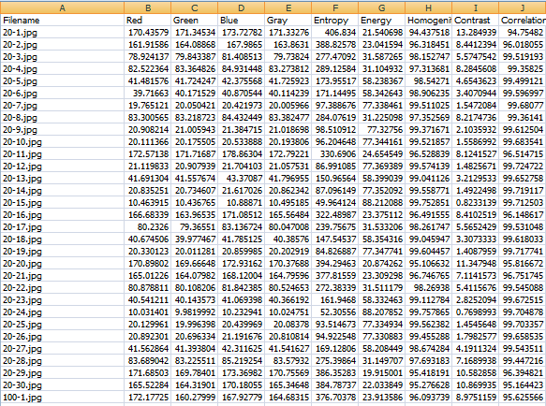

Clear a Data

axes(handles.axes1); cla;

axes(handles.axes2); cla;

set (handles.edit1, 'string',' ');

set (handles.edit2, 'string',' ');

Exit the System

close

Experiment Result

Thai Banknote Recognition System can recognize banknotes by 2 techniques which are Color Recognition and Euclidean distance Recognition. The experiment uses 12 pictures for each type of bank from the internet. For color recognition technique, it can recognize all pictures including both match and not match. Another technique which is euclidean distance recognition can find only 1 match from all 60 banknotes.

|  |  |  |  |  |  |  |
| --- | --- | --- | --- | --- | --- | --- |
| Type | Color Recognition | | | Euclidean distance Recognition | | |
| Result | Match | Miss Match | Unknown | Match | Miss Match | Unknown |
| 20 Baht | 6 | 6 | - | - | - | 12 |
| 50 Baht | 7 | 4 | - | - | - | 12 |
| 100 Baht | 12 | - | - | - | - | 12 |
| 500 Baht | 1 | 11 | - | 1 | - | 11 |
| 1,000 Baht | 1 | 11 | - | - | - | 12 |

Table 1: Result table from the experiment